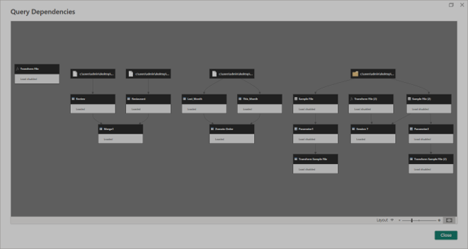
The boxes represent the different queries or tables used in the Power Query Editor. The arrows represent dependencies, showing that one query is using or being created from another query. Merge creates a dependency between related restaurant and review queries, while Append creates a dependency between the two order queries; Folder Combine creates dependencies through the sample-file transformation and the combined output.

